**5a]** MOVSB

PROGRAM:

section .text

global main

main:

mov ecx, len

mov esi, s1

mov edi, s2

cld

rep movsb

mov edx, 20

mov ecx, s2

mov ebx, 1

mov eax, 4

int 0x80

mov eax, 1

int 0x80

section .data

s1 db'hello,world!',0

len equ $-s1

section .bss

s2 resb 20

OUTPUT:

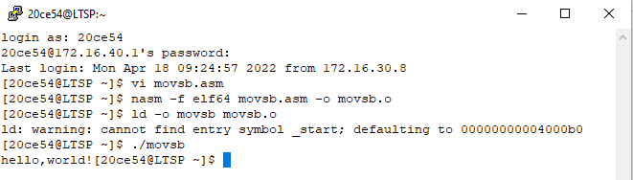

5b] CMSB

PROGRAM:

section .text

global main

main:

mov esi,s1

mov edi,s2

mov ecx,lens2

cld

repe cmpsb

jecxz equal

mov eax,4

mov ebx,1

mov ecx,msg_neq

mov edx,len_neq

int 80h

jmp exit

equal:

mov eax,4

mov ebx,1

mov ecx,msg_eq

mov edx,msg_eq

int 80h

exit:

mov eax,1

mov ebx,0

int 80h

section .data

s1 db 'Hello,world!',0;

lens1 equ $-s1

s2 db 'Hello!',0;

lens2 equ $-s2

msg_eq db 'Strings are equal!',0xa

len_eq equ $-msg_eq

msg_neq db 'Strings are not equal!',0xa

len_neq equ $-msg_neq

OUTPUT:

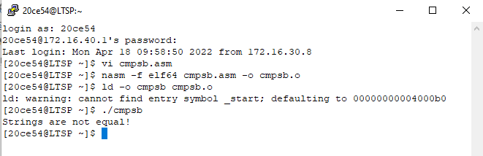

5c] STOSB

PROGRAM:

section .text

global main

main:

mov ecx,len

mov esi,s1

mov edi,s2

loop_here:

lodsb

or al,20h

stosb

loop loop_here

cld

rep movsb

mov edx,20

mov ecx,s2

mov ebx,1

mov eax,4

int 0x80

mov eax,1

int 0x80

section .data

s1 db 'Good morning',0

len equ $-s1

OUTPUT:

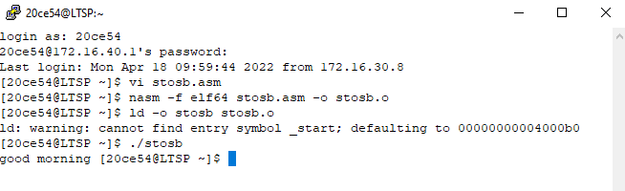

**5d]** SCAS

PROGRAM:

section .text

global _start

_start:

mov ecx,len

mov edi,my_string

mov al,'e'

cld

repne scasb

je found

mov eax,4

mov ebx,1

mov ecx,msg_notfound

mov edx,len_notfound

int 80h

jmp exit

found:

mov eax,4

mov ebx,1

mov ecx,msg_found

mov edx,len_found

int 80h

exit:

mov eax,1

mov ebx,0

int 80h

section .data

my_string db 'hello world',0

len equ $-my_string

msg_found db 'found!',0xa

len_found equ $-msg_found

msg_notfound db 'not found!'

len_notfound equ $-msg_notfound

OUTPUT:

